# IRIS Enterprise Software

# VAT Partial Exemption Plug-In

# User Documentation

# Version 6.00.008

|  |
| --- |
| Introduction This plug-in allows PIN and PCR transaction lines to be modified to automatically calculate the allowed & disallowed portions of partially exempt VAT. The VAT value against the expense line is to be recalculated based on the allowed percentage and the disallowed value of VAT is to be posted, as a separate transaction line, against the expense nominal code of the original entry. The original transaction values are to be stored in user defined fields within the transaction.  The percentage of chargeable VAT that is to be applied to partially exempt transactions will be based on a percentage constant set at the start of each quarter. |
| Limitations The following limitations will apply to the Plug-In:   * This Plug-In will require Exchequer v5.71 or above. * The Plug-In will only function within the core Accounts Application; it will not function for Exchequer for DOS or for any applications using the Import Modules or Toolkits to integrate with Exchequer. * The Plug-In will be outside of the scope of the password security for Exchequer. * The Plug-in will be multi company aware * The runtime licence for the Exchequer Toolkits will not be required. * The VAT codes Z, A and D set as default on a supplier account will overwrite any stock codes. * The Plug-In does not apply the Partial VAT on Purchase Orders (POR) or Purchase Deliveries (PDN). Any Purchase Invoices (PIN) converted from a POR or PDN will need to be edited to apply any partial VAT. * The Plug-In may need modifications for future changes to Exchequer, this should be checked with Technical Support prior to installing any upgrades * This Plug-In is not compatible with the purchase of Services from EC Traders |
| Contact Information Any queries about this Plug-In or requests for changes should be done through your existing point of contact. If that person is unavailable then contact can be made with the Bespoke Business Analyst at IRIS Enterprise Software Ltd on +44 (0)1202 298008. |

# Plug-In process

The VAT Partial Exemption Plug-in will reference VAT codes that are set against each Stock Code and a Percentage Constant that determines the allowed / disallowed portion of VAT.

### Stock Codes

Every expense item going through the Purchase Ledger is allocated a Stock Code. The Stock Code, which is entered against the Purchase Ledger transaction line, is the same as the GL Nominal Code assigned to that expense item.

A block of Stock Codes within the Exchequer Stock system will be used to maintain the list of expense Codes. Each Code will be a Description-Only type Stock Item and will have the Stock Code number set to the same number as the Nominal GL Code for the expense item. For example, Nominal Code 74001, ‘Test Supply One’, will have a corresponding description-only stock record 74001, ‘Test Supply One’.

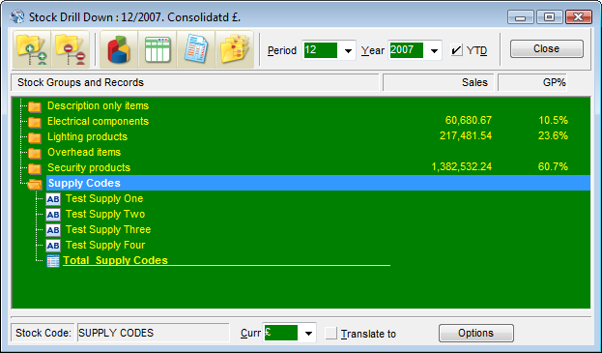

This structure allows a default VAT Code to be assigned to each Stock Code so that each Nominal Code is linked to a default VAT Code:

S - Standard Rate  
E – Exempt  
1 – Partially Exempt  
Z –Zero

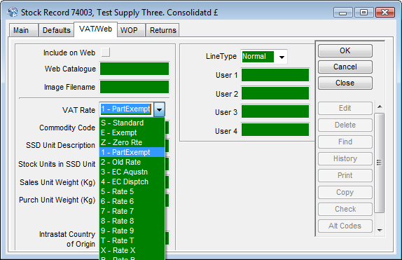

### VAT Rates

Within the Exchequer VAT Rates setup, a VAT Code is allocated for Part Exempt transactions and is set to the current standard rate (in this example we are using 17.50%).

A special VAT Code, Y, is also allocated to hold the Percentage Proportion Allowed that is to be applied to the Standard Rate of VAT for Partial Exempt transactions. This value will be set at the start of each quarter. This VAT Code will not actually be used against any transaction – it is simply used as a convenient way of storing the Percentage Proportion Allowed value within Exchequer.

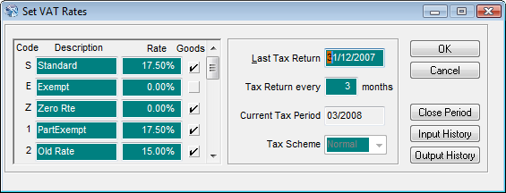



Using this structure, the allowed and disallowed portions of VAT for a quarter may be calculated as follows:

* Allowed = Part Exempt VAT Rate * Tax Prop Adj  
   = 17.50 * 0.70 = 12.25%
* Disallowed = Part Exempt VAT Rate * (100% – Tax Prop Adj)  
   = 17.50 * (1 – 0.70) = 5.25%

# Purchase Ledger Entry

The VAT Partial Exemption process within the Purchase Ledger operates as follows:

When a transaction line is entered on the Purchase Ledger, the user keys in the Stock Code relating to the type of expense. The system reads the Line Description, the GL Code and the default VAT code form the Stock Record.

Any Stock Codes that are VAT Part Exempt will have the VAT Code set to Part Exempt code. The user may change the VAT code if required.

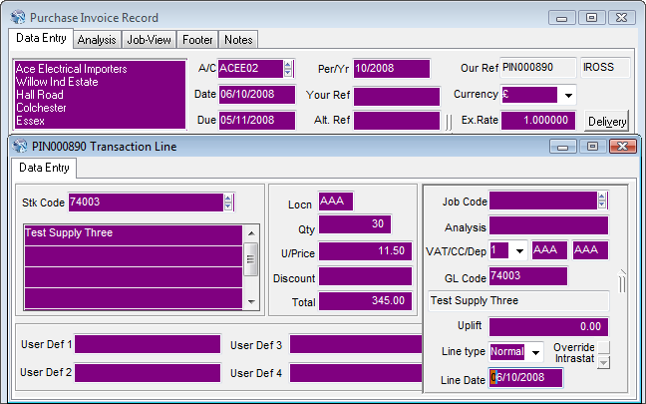

*Warning : note that if the default VAT code in the account record is set to Z, A or D then this will over-ride the Stock Code VAT setting.*

When the user has finished entering the transaction detail, he/she clicks on the OK button to save the transaction. At this stage, the data entry process has been using standard Exchequer functionality and the transaction should match the Supplier Invoice in terms of the Net Total and VAT Content values.

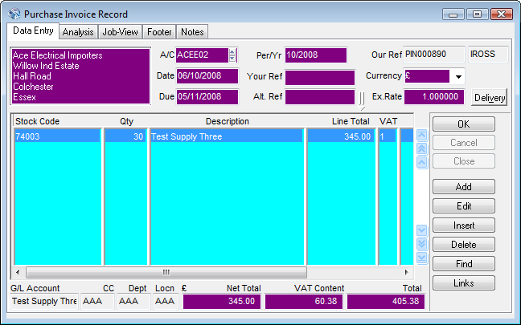

When the OK button is clicked, the VAT Partial Exemption Plug-In is activated. The Plug-In reads each transaction line and, for any line with a VAT Code set to the Partial Exempt VAT Code, will calculate the allowed and disallowed portions of VAT.

A Pop-Up box appears to confirm to the user the calculation has been made.

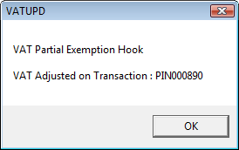

To calculate the allowed / disallowed portions of VAT, the Plug-In reads the Percentage Proportion Allowed value held against VAT Code Y (70%) and applies it to the VAT Rate against the transaction line VAT Code (17.50%). In our example, the allowed portion would be 70% of 17.50% = 12.25% and the disallowed portion would be 30% of 17.50% = 5.25%.

The Plug-In would then

* Recalculate the VAT value against the transaction line based on the allowed percentage:
  + 345.00 x 12.25 % = 42.26
* Create a new VAT Exempt transaction line, using the same supply code as the original line, with a net value based on the disallowed VAT portion percentage applied to the original transaction value:
  + 345.00 x 5.25 % = 18.12 (adjusted for rounding)

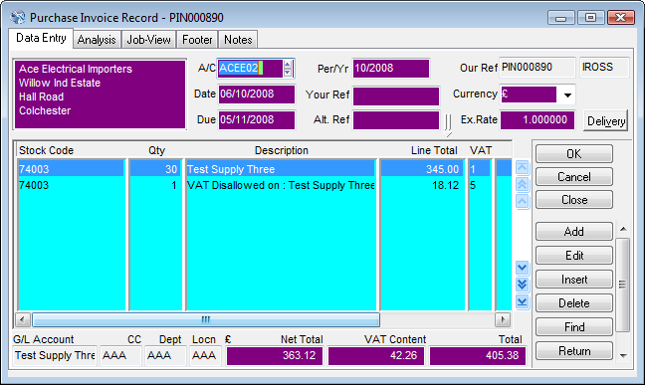

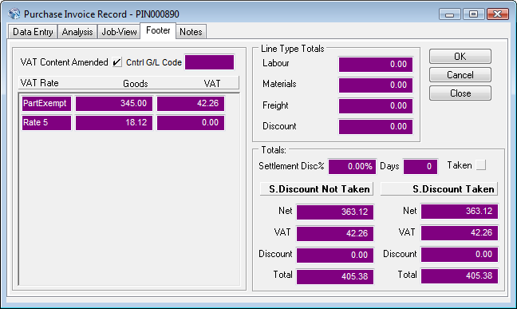

### Exchequer Forms

Note that the Exchequer Forms used for printing PINs and PCRs will need to be modified to pick up the original transaction values from the transaction user defined fields.

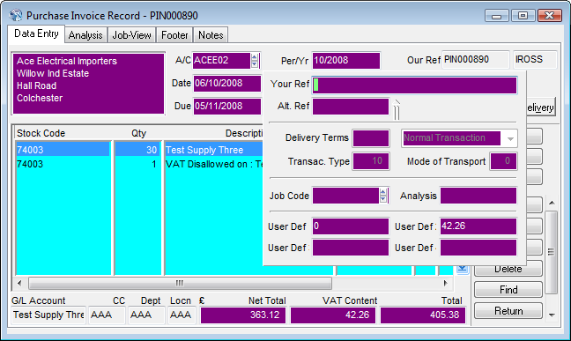

User defined field one on the header part of the transaction holds the total for S code (standard) VAT

User defined field two on the header part of the transaction holds the total for 1 code (partial exempt) VAT

User defined field one on the transaction line will hold “DVA” to signify that this is an adjustment line for disallowed VAT. If set, the line is skipped in forms print.

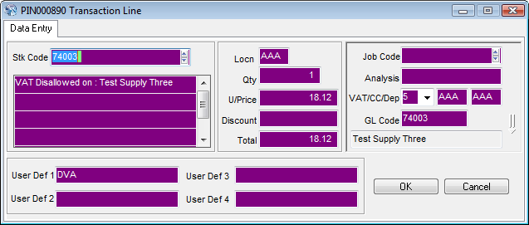

User defined field two on the transaction line holds the original VAT percentage

User defined field three on the transaction line holds the original line VAT value.

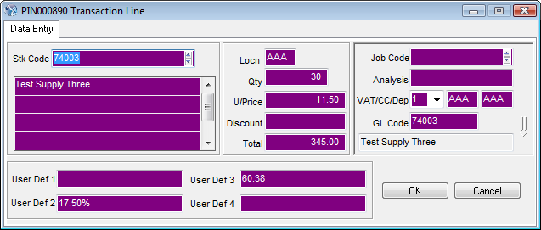

Captions for the User defined fields can be edited from Utilities, System Setup, General Settings, Custom Fields

# Installation Instructions

The IRIS Exchequer VAT Partial Exemption Plug-in Consists of the following files:

Filename Description  
VATPEX.DLL VAT Partial Exemption Plug-In  
VATUPD.EXE VAT Partial Exemption Configuration Application

Following a full and complete backup and with no users accessing IRIS Exchequer, select and run the @VATPartExc.exe application from the ‘PlugIns\VAT Partial Exemption’ folder found on the IRIS Exchequer Install CD provided, or from the .ZIP file if applicable.

Follow the wizard through ensuring the correct path is stated on the last screen.

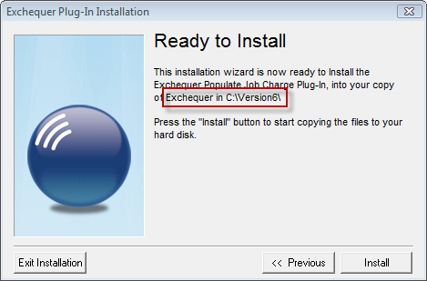

To verify the installation was successful, open IRIS Exchequer in the normal manner. When IRIS Exchequer is open, from the menu options ‘Help’, ‘About’ screen, position your mouse inside the text field and scroll down to reveal the ‘VAT Partial Exemption Plug-In’ details as follows:

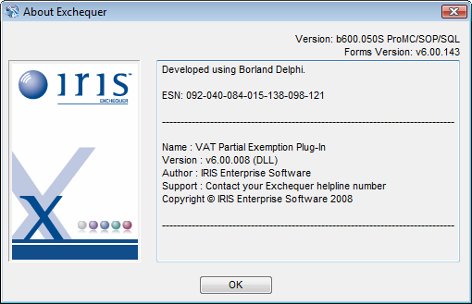

This completes the installation of the Plug-In.